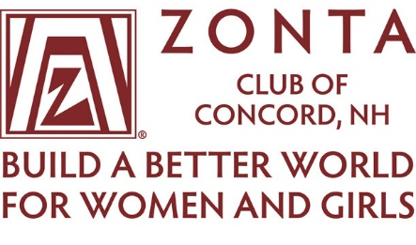

Zonta Club of Concord, NH
Jane M. Klausman Women in Business Scholarship
Application Available

The Zonta Club of Concord is taking applications for the Jane M. Klausman Women in Business Scholarship. The application period begins immediately and the application deadline is April 30, 2024. This scholarship is designed to encourage women to pursue careers and to seek leadership positions in business and information technology related fields in their communities and throughout the world. JMK Scholarships look to the women of today to be the leaders of tomorrow.

Any New Hampshire woman undertaking a business or information technology related degree programs at an accredited university/college/institute, and is in at least the second year of an undergraduate program through the final year of a master’s program (and not completing degree requirements until 2025) at the time the application is submitted is eligible to apply.

The recipient of the Club’s $2000 award may then be eligible to have their application submitted to Zonta District 1. The District 1 scholarship evaluation committee will then determine if that application should be sent to Zonta International for consideration as a recipient for one of 37 international awards of $5000.

The application and additional eligibility requirements are available online at the Zonta Club of Concord NH website, http://www.zontaclubofconcordnh.org under the “what we do” then “scholarships” tabs or by emailing Catherine Barrows at concordzontajmk@gmail.com.

