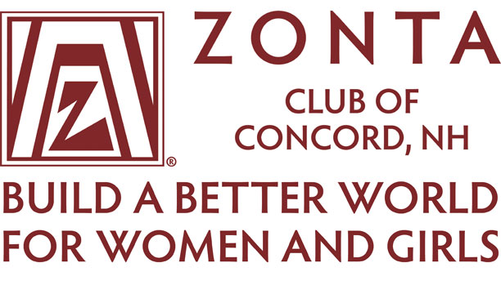

Zonta of Concord wishes to extend an invitation for qualified students attending your institution to apply for our Memorial Scholarship.

Zonta Memorial Scholarship is for non-traditional female students returning to college after five-plus years. Since 2006, thanks to the generosity of Zonta members and our friends, family and co-workers, the club has been able to award over $53,000 to women who had a financial need in order to continue their education.
Financial assistance is to be used for tuition and/or college fees.
Applicants must have completed 12 college credit hours at an accredited college or university - with a GPA of 2.5 or higher. Please provide proof of the 2.5 GPA and the minimum 12 credit hours.
You may send your transcript to:
Zonta Club of Concord NH
PO Box 1736
Concord, NH 03302
Or by email to: zontaclubofconcordnh@gmail.com

Click here for the 2024 Memorial Scholarship application

Incomplete applications will not be considered.
Additional information is available at zontaclubofconcordnh.org
Please contact Amanda Bailey, Zonta Club of Concord NH, Memorial Scholarship
at mandybaileynh@Yahoo.com for any assistance

Deadline is March 30th, 2024

